THREE STAGE AND OPERATION

PROGRAM:

#include <stdio.h>

// Function to perform a three-stage AND operation int threeStageAndOperation(int a, int b, int c) { // Perform first AND operation: A & B int stage1 = a & b;

// Perform second AND operation: (A & B) & C

int stage2 = stage1 & c;

return stage2;

}

int main() {

int a, b, c;

// Input three integers (we can treat them as bits: 0 or 1) printf("Enter first value (0 or 1): "); scanf("%d", &a);

printf("Enter second value (0 or 1): "); scanf("%d", &b);

printf("Enter third value (0 or 1): "); scanf("%d", &c);

// Ensure inputs are either 0 or 1 if((a != 0 && a != 1) || (b != 0 && b != 1) || (c != 0 && c != 1)) { printf("Invalid input! Please enter only 0 or 1.\n");

return 1;

}

// Perform three-stage AND operation int result = threeStageAndOperation(a, b, c);

// Output the result printf("Result of three-stage AND operation: %d\n", result);

return 0;

}

INPUT & OUTPUT :

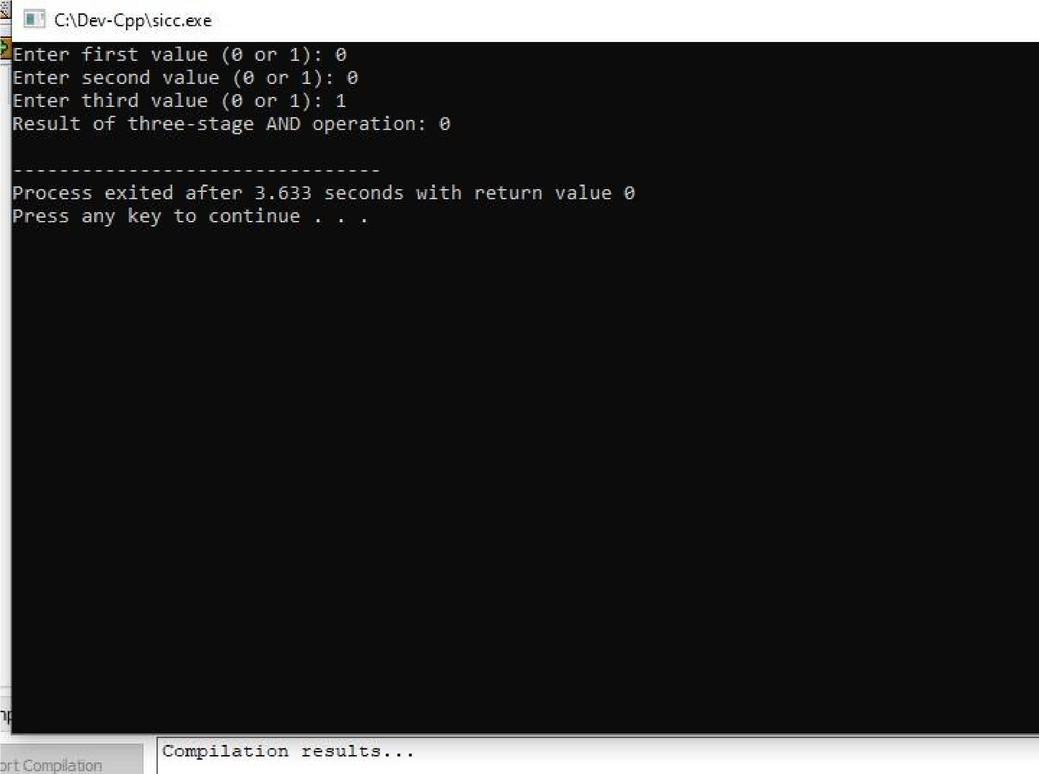

**RESULT:** Thus the program was executed successfully using DevC++.